Indiana FFA elects new State Officers
FOR IMMEDIATE RELEASE
7 members from across Indiana are elected to serve as student leaders for the year
Indianapolis, Indiana (June 16, 2022) – The Indiana FFA Convention was held at the Indiana State Fairgrounds for the second time in the organization’s history. Sessions were held at the Indiana State Fairgrounds, with judging events held at Hamilton Southeastern High School, and some banquets and workshops held at Conner Prairie.

The following members were named to the 2022-2023 Indiana FFA State Officer team:

President – Seth Ariens, North Putnam
Secretary – Tobias Sturgell, Indian Creek
Northern Region Vice President – Mary Jones, Adams Central
Southern Region Vice President – Jenna Kelsay, Whiteland
Treasurer – Anthony Taylor, Warsaw
Reporter – Gracie Lee, Monroe Central
Sentinel – Jaden Maze, Western Boone

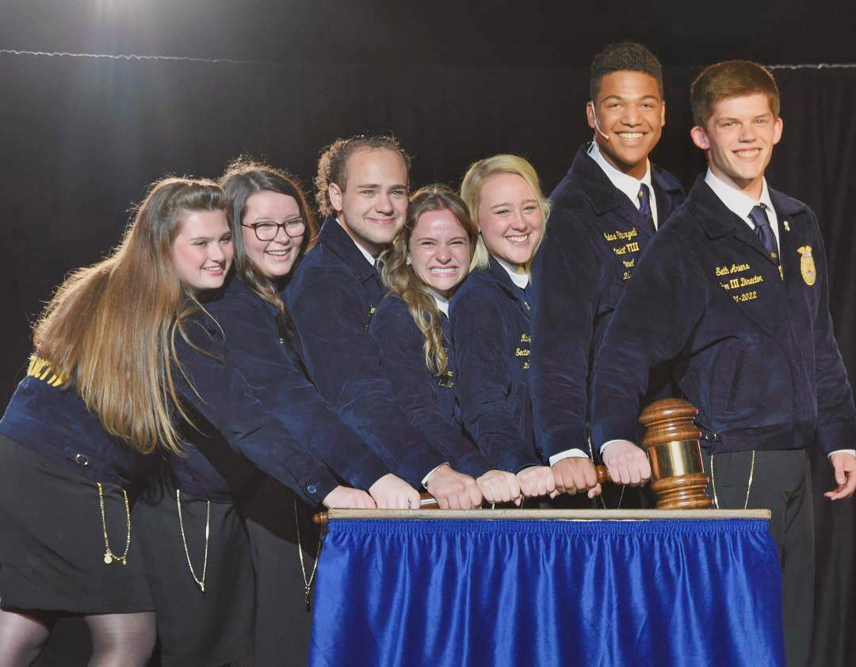

###

About the Indiana FFA Association - The Indiana FFA is the largest Career and Technical Student Organization in Indiana with nearly 12,000 members as part of 219 local FFA chapters across the state. The FFA mission is to make a positive difference in the lives of students by developing their potential for premier leadership, personal growth and career success. The Indiana State Department of Agriculture provides leadership and direction for the Indiana FFA as a service to local agricultural education programs. For more information, visit the Indiana FFA webpage at inffa.org, or follow the conversation on Twitter, Facebook, Instagram and BlogSpot.

Media Contacts:
Erin Padgett (epadgett@isda.in.gov or 317-910-5111)

