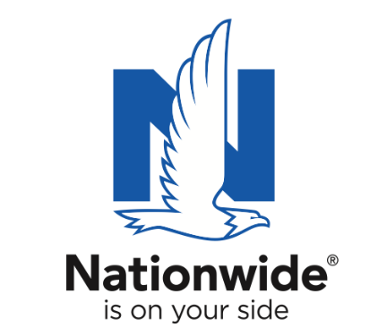
FOR IMMEDIATE RELEASE

June 16, 2022

Contact:
Bethany Eippert
614-249-6349
eippeb2@nationwide.com

Indiana Agricultural Teacher Named
“Ag Educator of the Year”

Indianapolis, IN – Blair Orme honored as Indiana’s Golden Owl Award grand prize winner after being named one of 8 state finalists

Des Moines, IA – Agricultural educators across the nation are devoted to making meaningful connections and encouraging the development of their students. In Indiana, eight exceptional ag teachers were named as finalists for the Golden Owl Award® for their positive impact in the classroom and industry overall. Of the finalists, Orme, an agricultural teacher at Rushville Consolidated High School, was named Indiana’s 2021-2022 “Ag Educator of the Year.”

Nationwide, in partnership with the Indiana FFA and other partners, recognized Orme as the 2021-2022 Golden Owl Award grand prize winner during the Indiana FFA State Convention. In addition to the title of Indiana’s Ag Educator of the Year, Orme will receive the coveted Golden Owl Award trophy and a $3,000 Nationwide-funded donation to further Rushville’s agricultural education efforts.

Orme’s nominations described him as hardworking, dedicated, and well respected within the agricultural education community. One nomination read, “The impact that Dr. Retallick continues to have on others within agricultural education at the state, national, and international levels is immense and immeasurable.” Another one states, “Not only is Mr. Orme a phenomenal educator, though, he’s a life changing individual that has positively impacted the lives of hundreds of students that have walked the halls of RCHS and other Indiana FFA members.”

As the number one insurer of farms and ranches in the United States¹, Nationwide established the Golden Owl Award with its state partners to shed light on the contributions of Indiana’s leading agricultural teachers and provide additional resources to support their programs.

“Nationwide is proud to recognize the dedicated men and women who are educating and inspiring students to pursue careers in agriculture,” said Brad Liggett, Nationwide’s president of Agribusiness. “We’re honored to have the opportunity to appreciate their contributions, highlight the growing need for their services, and supply additional resources to help provide students with optimal learning experiences.”

Nationwide supports the future of the ag community through meaningful sponsorships of national and local organizations. In conjunction with the Golden Owl Award, Nationwide is donating $5,000 to each participating state’s FFA, including the Indiana FFA, to further support the personal and professional growth of students, teachers and advisors alike.

The Golden Owl Award is the result of a partnership between Nationwide, the California FFA, California Farm Bureau, Illinois FFA, Illinois Association of Vocational Agriculture Teachers, Farm Credit Illinois, Indiana FFA, Farm Credit Mid-America, the Iowa FFA Foundation, New York FFA, New York Farm Bureau, Ohio FFA, Ohio Farm Bureau, Pennsylvania FFA, Pennsylvania Farm Bureau, Compeer Financial and AgCredit.

For more information, visit www.goldenowlaward.com.

¹ Source: A.M. Best Market Share Report 2021

About Nationwide
Nationwide, a Fortune 100 company based in Columbus, Ohio, is one of the largest and strongest diversified insurance and financial services organizations in the United States. Nationwide is rated A+ by both A.M. Best and Standard & Poor’s. An industry leader in driving customer-focused innovation, Nationwide provides a full range of insurance and financial services products including auto, business, homeowners, farm and life insurance; public and private sector retirement plans, annuities, mutual funds and EFTs; excess & surplus, specialty and surety; and pet, motorcycle and boat insurance. For more information, visit www.nationwide.com. Follow the firm on Facebook and Twitter.

Nationwide, Nationwide is on your side and the Nationwide N and Eagle are service marks of Nationwide Mutual Insurance Company. © 2022

